Project Design Phase-II

Data Flow Diagram & User Stories

Date | 2 November 2025
Team ID | NM2025TMID00454
Project Name | Calculating Family Expenses using Service Now
Maximum Marks | 4 Marks

Data Flow Diagrams:
A Data Flow Diagram (DFD) visually represents how data moves through the Family Expense Calculation System built on ServiceNow. It shows how users enter, categorize, and calculate expenses, and how the system processes and stores data for summary and reporting.
In the project “Calculating Family Expenses using ServiceNow,” the DFD illustrates interactions between users, the ServiceNow application, and the expense database.
Users add daily expenses, which are stored and categorized by the system. The system calculates total monthly and yearly expenses and generates reports for better financial insights.
Example:
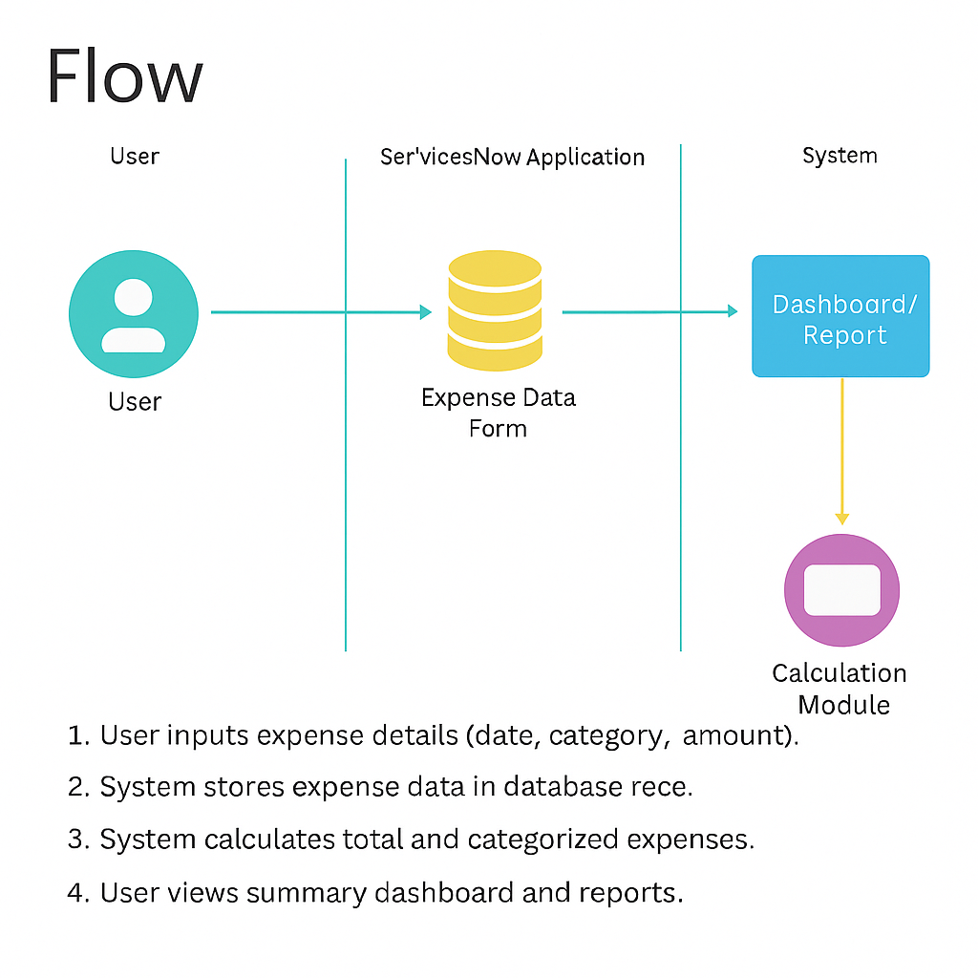

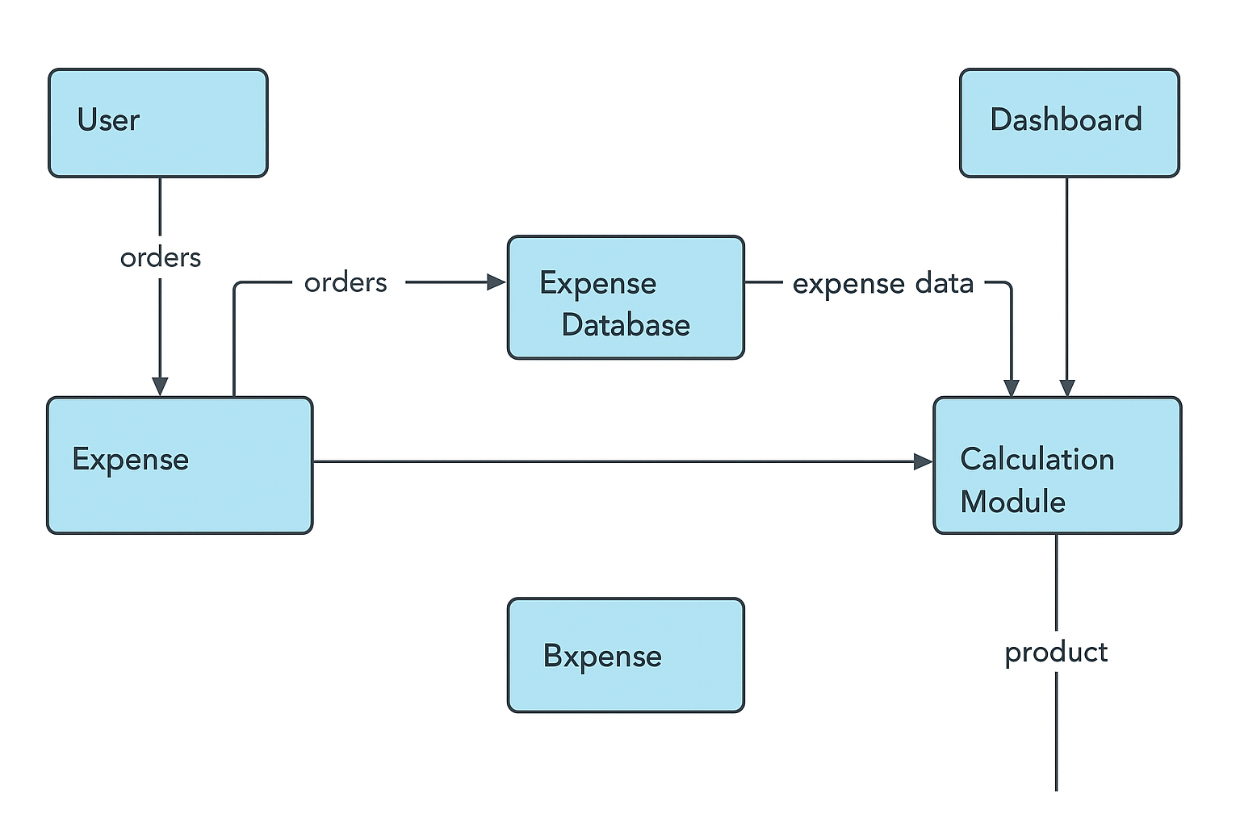
User Stories:

User stories define what different users need from the system in simple, goal-focused language. For this project, they describe how family members can record, view, and analyze expenses using ServiceNow.

User Type | Functional  Requirement (Epic) | User Story Number | User Story / Task | Acceptance criteria | Priority | Release
Family Member | Expense Entry | USN-1 | As a user, I want to enter daily expenses with category and amount. | The system should allow adding expenses and saving them successfully. | High | Sprint-1
System | Expense Calculation | USN-2 | As a system, I should automatically calculate total and categorized expenses. | Totals must update automatically when new data is entered. | High | Sprint-2
Family Member | Dashboard | USN-3 | As a user, I want to view monthly and yearly expense summaries on a dashboard. | Dashboard must display accurate, updated visual summaries. | High | Sprint-3
Admin | Budget Setup | USN-4 |  | System should trigger alerts when expenses cross budget limits. | Medium | Sprint-3
  As an admin, I want to set monthly budget
  limits and get alerts when exceeded.
User | Data Export | USN-5 | As a user, I want to export expense reports in Excel or PDF. | Reports must download in selected format with correct totals. | Medium | Sprint-4

